ITA0305- Mobile Computing
LAB EXPERIMENT
Name: G.Ganesh
Reg NO:192373008

3) Develop a flowchart in Figma depicting the operation of a Network Switching
Subsystem in a mobile cellular system.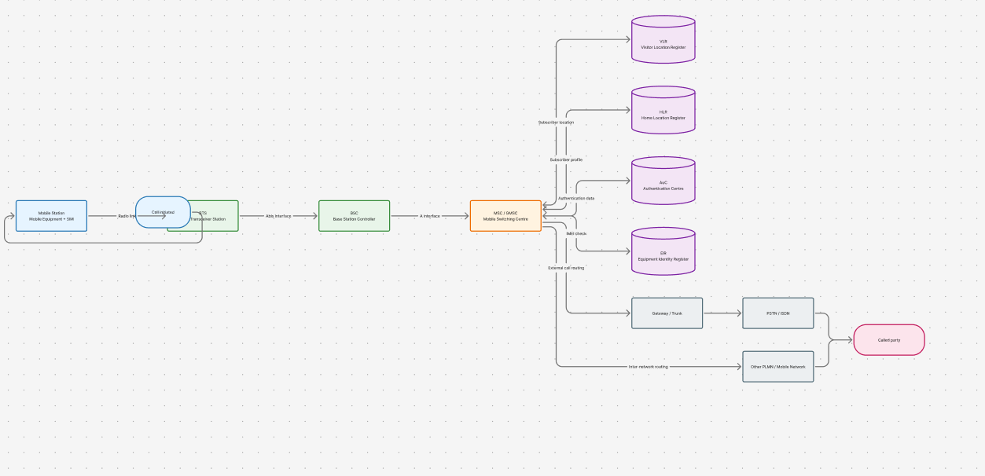
https://www.figma.com/board/EzOI7ov7DP5SGdOKcrUgJP/program03?node-id=0-1&p=f&t=HvsXhctLHLD33bvs-0

